DSA ALL EXPERIMENTS
Title
C Program to Display a Right-Angle Triangle with Numbers
Program to implement pattern using C:
#include <stdio.h>

int main() {
int n, i, j;

printf("Enter number of rows: ");
scanf("%d", &n);

printf("\nRight-Angle Triangle with Numbers:\n");
for (i = 1; i <= n; i++) {
for (j = 1; j <= i; j++) {
printf("%d ", j);
}
printf("\n");
}

return 0;
}
Output:
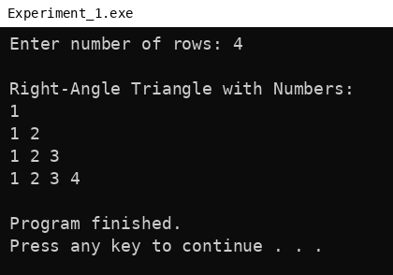

Title
C Program to Display a Diamond Shape with Numbers
Program to implement pattern using C:
#include <stdio.h>

int main() {
int n, i, s, j;

printf("Enter number of rows: ");
scanf("%d", &n);

printf("\nDiamond Shape with Numbers:\n");

// Upper half
for (i = 1; i <= n; i++) {
for (s = 1; s <= n - i; s++) {
printf(" ");
}
for (j = 1; j <= i; j++) {
printf("%d ", j);
}
printf("\n");
}

// Lower half
for (i = n - 1; i >= 1; i--) {
for (s = 1; s <= n - i; s++) {
printf(" ");
}
for (j = 1; j <= i; j++) {
printf("%d ", j);
}
printf("\n");
}

return 0;
}
Output:
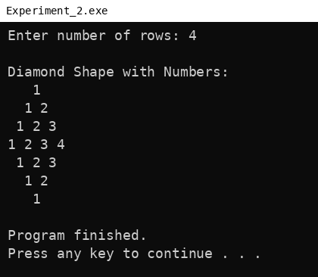
Title
C Program to Display a Pyramid with Asterisks
#include <stdio.h>

int main() {
int n, i, s, j;

printf("Enter number of rows: ");
scanf("%d", &n);

printf("\nPyramid with Asterisks:\n");
for (i = 1; i <= n; i++) {
for (s = 1; s <= n - i; s++) {
printf(" ");
}
for (j = 1; j <= (2 * i - 1); j++) {
printf("*");
}
printf("\n");
}

return 0;
}
Output:
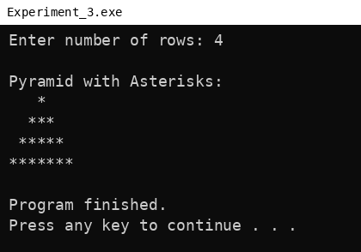

Title:
Student Database Management System using C
C Program to Implement Student Database Management.
#include <stdio.h>
#include <string.h>

#define MAX 100 // Maximum number of students
#define SUBJECTS 3 // Total number of subjects per student

// Define a structure to store student details
struct Student {
int rollNo; // Roll number of the student
char name[50]; // Name of the student
int marks[SUBJECTS]; // Marks in 3 subjects
int total; // Total marks of all subjects
float average; // Average marks
};

// Global array to store all students and variable to count them
struct Student students[MAX];
int count = 0;

// Function to add a new student record
void addStudent() {
if (count >= MAX) {
printf("No space to add more students.\n");
return;
}

struct Student s; // Temporary variable to store new student data

// Input student roll number
printf("\nEnter Roll No: ");
scanf("%d", &s.rollNo);

// Input student name
printf("Enter Name: ");
scanf(" %[^\n]", s.name); // %[^\n] allows reading full name with spaces

// Input marks for each subject
s.total = 0;
printf("Enter marks for %d subjects:\n", SUBJECTS);
int i;
for (i = 0; i < SUBJECTS; i++) {
printf("Subject %d: ", i + 1);
scanf("%d", &s.marks[i]);
s.total += s.marks[i]; // Add marks to total
}

// Calculate average marks
s.average = s.total / (float)SUBJECTS;

// Add the student record to the global array
students[count++] = s;

printf("Student added successfully!\n");
}

// Function to display all student records
void displayStudents() {
if (count == 0) {
printf("No students to display.\n");
return;
}

// Print table header
printf("\n%-5s %-20s %-10s %-10s\n", "Roll", "Name", "Total", "Average");

int i;
// Loop through all students and display their details
for (i = 0; i < count; i++) {
printf("%-5d %-20s %-10d %-10.2f\n",
students[i].rollNo,
students[i].name,
students[i].total,
students[i].average);
}
}

// Function to search for a student by roll number
void searchStudent() {
int roll;
printf("Enter Roll No to search: ");
scanf("%d", &roll);

int i;
// Loop through all student records to find a match
for (i = 0; i < count; i++) {
if (students[i].rollNo == roll) {
printf("\nStudent Found:\n");
printf("Name: %s\n", students[i].name);
printf("Total: %d\n", students[i].total);
printf("Average: %.2f\n", students[i].average);

// Print marks in each subject
printf("Marks: ");
int j;
for (j = 0; j < SUBJECTS; j++) {
printf("%d ", students[i].marks[j]);
}
printf("\n");
return; // Exit the function after finding the student
}
}

// If no match found
printf("Student with Roll No %d not found.\n", roll);
}

// Function to sort students by their average marks in descending order
void sortStudents() {
if (count < 2) {
printf("Not enough students to sort.\n");
return;
}

int i, j;
// Using Bubble Sort algorithm to sort by average marks
for (i = 0; i < count - 1; i++) {
for (j = 0; j < count - i - 1; j++) {
if (students[j].average < students[j + 1].average) {
// Swap records if not in correct order
struct Student temp = students[j];
students[j] = students[j + 1];
students[j + 1] = temp;
}
}
}

printf("Students sorted by average marks.\n");
}

// Main function: Menu-driven program
int main() {
int choice;

do {
// Display the main menu
printf("\n--- Student Management System ---\n");
printf("1. Add Student\n");
printf("2. Display All Students\n");
printf("3. Search by Roll Number\n");
printf("4. Sort by Average Marks\n");
printf("5. Exit\n");
printf("Enter your choice: ");
scanf("%d", &choice);

// Perform operation based on user choice
switch (choice) {
case 1:
addStudent();
break;
case 2:
displayStudents();
break;
case 3:
searchStudent();
break;
case 4:
sortStudents();
break;
case 5:
printf("Exiting...\n");
break;
default:
printf("Invalid choice. Try again.\n");
}

} while (choice != 5); // Repeat menu until user chooses to exit

return 0;
}

Output:
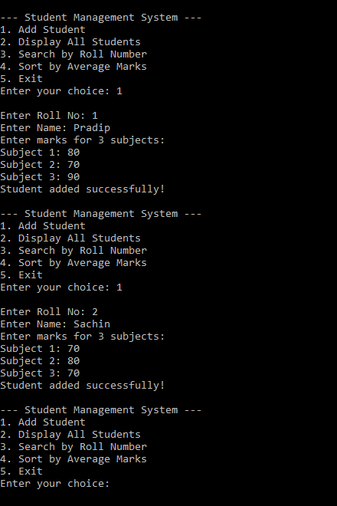

Title:
Searching Techniques – Linear Search
#include <stdio.h>

int main()
{
int arr[100], n, i, key, found = 0;

// Input number of elements
printf("Enter the number of elements: ");
scanf("%d", &n);

// Input array elements
printf("Enter %d elements: ", n);
for (i = 0; i < n; i++)
{
scanf("%d", &arr[i]);
}

// Input element to search
printf("Enter the element to search: ");
scanf("%d", &key);

// Linear Search
for (i = 0; i < n; i++)
{
if (arr[i] == key)
{
found = 1;
break;
}
}

// Display result
if (found == 1)
{
printf("Element found at index %d\n", i);
printf("Position: %d\n", i + 1);
}
else
{
printf("Element not found\n");
}

return 0;
}

Title:
Searching Techniques –Binary Search

#include <stdio.h>

int main()
{
int arr[100], n, i, key;
int low, high, mid, found = 0;

// Input number of elements
printf("Enter the number of elements: ");
scanf("%d", &n);

// Input sorted array elements
printf("Enter %d elements in ascending order: ", n);
for (i = 0; i < n; i++)
{
scanf("%d", &arr[i]);
}

// Input element to search
printf("Enter the element to search: ");
scanf("%d", &key);

// Initialize boundaries
low = 0;
high = n - 1;

// Binary Search
while (low <= high)
{
mid = low + (high - low) / 2;

if (arr[mid] == key)
{
found = 1;
break;
}
else if (arr[mid] < key)
{
low = mid + 1;
}
else
{
high = mid - 1;
}
}

// Display result
if (found == 1)
{
printf("Element found at index %d\n", mid);
printf("Position: %d\n", mid + 1);
}
else
{
printf("Element not found\n");
}

return 0;
}

Title : Sorting Algorithms Implementation of Bubble Sort in C

#include <stdio.h>

int main()
{
float arr[100], temp;
int n, i, j;

printf("Enter the number of elements: ");
scanf("%d", &n);

printf("Enter %d prices: ", n);
for (i = 0; i < n; i++)
{
scanf("%f", &arr[i]);
}

// Bubble Sort
for (i = 0; i < n - 1; i++)
{
for (j = 0; j < n - i - 1; j++)
{
if (arr[j] > arr[j + 1])
{
temp = arr[j];
arr[j] = arr[j + 1];
arr[j + 1] = temp;
}
}
}

printf("Prices after Bubble Sort:\n");
for (i = 0; i < n; i++)
{
printf("%.2f ", arr[i]);
}

return 0;
}

Title : Sorting Algorithms Implementation of Selection Sort in C.

#include <stdio.h>

int main()
{
float arr[100], temp;
int n, i, j, minIndex;

printf("Enter the number of elements: ");
scanf("%d", &n);

printf("Enter %d prices: ", n);
for (i = 0; i < n; i++)
{
scanf("%f", &arr[i]);
}

// Selection Sort
for (i = 0; i < n - 1; i++)
{
minIndex = i;

for (j = i + 1; j < n; j++)
{
if (arr[j] < arr[minIndex])
{
minIndex = j;
}
}

// Swap minimum element
temp = arr[minIndex];
arr[minIndex] = arr[i];
arr[i] = temp;
}

printf("Prices after Selection Sort:\n");
for (i = 0; i < n; i++)
{
printf("%.2f ", arr[i]);
}

return 0;
}

Title : Sorting Algorithms Implementation of Insertion Sort in C.

#include <stdio.h>

int main()
{
float arr[100], key;
int n, i, j;

printf("Enter the number of elements: ");
scanf("%d", &n);

printf("Enter %d prices: ", n);
for (i = 0; i < n; i++)
{
scanf("%f", &arr[i]);
}

// Insertion Sort
for (i = 1; i < n; i++)
{
key = arr[i];
j = i - 1;

while (j >= 0 && arr[j] > key)
{
arr[j + 1] = arr[j];
j--;
}

arr[j + 1] = key;
}

printf("Prices after Insertion Sort:\n");
for (i = 0; i < n; i++)
{
printf("%.2f ", arr[i]);
}

return 0;
}

Title:
Implementation of Stack Using Array in C.
C Program Code:
#include <stdio.h>
#include <stdlib.h>

#define MAX 100 // Maximum size of stack

int stack[MAX]; // Array to store stack elements
int top = -1; // Variable to keep track of the top element index (-1 means stack is empty)

// Function to push element onto stack
void push(int value) {
if (top == MAX - 1) { // Check if stack is full
printf("Stack Overflow! Cannot push %d\n", value);
} else {
top++; // Increment top index
stack[top] = value; // Insert the value at top
printf("Pushed %d to stack.\n", value);
}
}

// Function to pop element from stack
void pop() {
if (top == -1) { // Check if stack is empty
printf("Stack Underflow! Cannot pop.\n");
} else {
printf("Popped %d from stack.\n", stack[top]);
top--; // Decrement top index
}
}

// Function to return the top element without removing it
void peek() {
if (top == -1) { // Check if stack is empty
printf("Stack is Empty.\n");
} else {
printf("Top element is %d\n", stack[top]);
}
}

// Function to display all stack elements
void display() {
int i;
if (top == -1) { // Check if stack is empty
printf("Stack is Empty.\n");
} else {
printf("Stack elements (top to bottom):\n");
for (i = top; i >= 0; i--) { // Print from top to bottom
printf("%d\n", stack[i]);
}
}
}

// Main function with menu-driven program
int main() {
int choice, value;

while (1) { // Infinite loop until user chooses to exit
printf("\n--- Stack Menu ---\n");
printf("1. Push\n2. Pop\n3. Peek\n4. Display\n5. Exit\n");
printf("Enter your choice: ");
scanf("%d", &choice);

switch (choice) {
case 1:
printf("Enter value to push: ");
scanf("%d", &value);
push(value); // Call push function
break;
case 2:
pop(); // Call pop function
break;
case 3:
peek(); // Call peek function
break;
case 4:
display(); // Call display function
break;
case 5:
exit(0); // Exit the program
default:
printf("Invalid choice! Try again.\n");
}
}

return 0;
}

Title:
Implementation of Singly Linked List Operations in C
#include <stdio.h>
#include <stdlib.h>

struct Node
{
int data;
struct Node *next;
};

struct Node *head = NULL;

// Insert at end
void insert(int value)
{
struct Node *newNode, *temp;
newNode = malloc(sizeof(struct Node));

newNode->data = value;
newNode->next = NULL;

if (head == NULL)
head = newNode;
else
{
temp = head;
while (temp->next != NULL)
temp = temp->next;
temp->next = newNode;
}
}

// Display list
void display()
{
struct Node *temp = head;

if (temp == NULL)
printf("List is empty\n");

while (temp != NULL)
{
printf("%d -> ", temp->data);
temp = temp->next;
}
printf("NULL\n");
}

// Search element
void search(int key)
{
struct Node *temp = head;

while (temp != NULL)
{
if (temp->data == key)
{
printf("Element found\n");
return;
}
temp = temp->next;
}
printf("Element not found\n");
}

// Delete a node by value
void deleteNode(int key)
{
struct Node *temp = head, *prev = NULL;

while (temp != NULL && temp->data != key)
{
prev = temp;
temp = temp->next;
}

if (temp == NULL)
{
printf("Element not found\n");
return;
}

if (prev == NULL)
head = temp->next;
else
prev->next = temp->next;

free(temp);
printf("Node deleted\n");
}

int main()
{
int choice, value;

while (1)
{
printf("\n1.Insert 2.Display 3.Search");
printf("\n4.Delete 5.Exit");
printf("\nEnter choice: ");
scanf("%d", &choice);

switch (choice)
{
case 1:
printf("Enter value: ");
scanf("%d", &value);
insert(value);
break;

case 2:
display();
break;

case 3:
printf("Enter value to search: ");
scanf("%d", &value);
search(value);
break;

case 4:
printf("Enter value to delete: ");
scanf("%d", &value);
deleteNode(value);
break;

case 5:
exit(0);

default:
printf("Invalid choice\n");
}
}

return 0;
}

Title
Decimal to Binary Conversion Using Stack

C Program
#include <stdio.h>

#define MAX 32

// Function to push an element into the stack
void push(int stack[], int *top, int value)
{
// Check for stack overflow
if (*top == MAX - 1)
{
printf("Stack Overflow!\n");
return;
}

(*top)++;
stack[*top] = value;
}

// Function to pop an element from the stack
int pop(int stack[], int *top)
{
// Check for stack underflow
if (*top == -1)
{
printf("Stack Underflow!\n");
return -1;
}

int value = stack[*top];
(*top)--;

return value;
}

int main()
{
int stack[MAX];
int top = -1;
int decimal, remainder;

// Read decimal number from the user
printf("Enter a decimal number: ");
scanf("%d", &decimal);

// Special case for decimal number 0
if (decimal == 0)
{
printf("Binary equivalent = 0\n");
return 0;
}

// Convert decimal number to binary
while (decimal > 0)
{
// Find remainder after division by 2
remainder = decimal % 2;

// Store remainder in the stack
push(stack, &top, remainder);

// Divide decimal number by 2
decimal = decimal / 2;
}

// Display binary number by popping elements
printf("Binary equivalent = ");

while (top != -1)
{
printf("%d", pop(stack, &top));
}

printf("\n");

return 0;
}

Output
Enter a decimal number: 25
Binary equivalent = 11001

Title:
Implementation of Stack Operations (Push, Pop, Peek, Display) using Singly Linked List.
C programming Code for Stack using Linked list :
#include <stdio.h>
#include <stdlib.h>

// Node structure for stack
struct Node
{
int data; // Data of the node
struct Node* next; // Pointer to the next node in stack
};

// Pointer to the top of the stack
struct Node* top = NULL;

// Function to push an element onto the stack
void push(int value)
{
struct Node* newNode = (struct Node*) malloc(sizeof(struct Node)); // Allocate memory for new node
newNode->data = value; // Assign value to node
newNode->next = top; // Link new node to current top
top = newNode; // Update top to new node
printf("%d pushed to stack.\n", value);
}

// Function to pop an element from the stack
void pop()
{
if (top == NULL)
{ // Check for underflow
printf("Stack Underflow! Cannot pop.\n");
return;
}
struct Node* temp = top; // Store current top
printf("%d popped from stack.\n", temp->data);
top = top->next; // Move top to next node
free(temp); // Free memory of popped node
}

// Function to view the top element of the stack
void peek() {
if (top == NULL) { // If stack is empty
printf("Stack is empty.\n");
return;
}
printf("Top element is %d\n", top->data); // Print top element
}

// Function to display all elements in the stack
void display() {
struct Node* temp = top; // Start from top
if (temp == NULL) { // If stack is empty
printf("Stack is empty.\n");
return;
}
printf("Stack elements (top to bottom):\n");
while (temp != NULL) { // Traverse till the end
printf("%d\n", temp->data);
temp = temp->next; // Move to next node
}
}

// Main function: menu-driven program
int main() {
int choice, value;

while (1) { // Infinite loop for menu
// Display menu options
printf("\n--- Stack Menu ---\n");
printf("1. Push\n");
printf("2. Pop\n");
printf("3. Peek\n");
printf("4. Display\n");
printf("5. Exit\n");
printf("Enter your choice: ");
scanf("%d", &choice);

switch (choice)
{
// Execute operation based on user choice
case 1:
printf("Enter value to push: ");
scanf("%d", &value);
push(value); // Call push function
break;
case 2:
pop(); // Call pop function
break;
case 3:
peek(); // Call peek function
break;
case 4:
display(); // Call display function
break;
case 5:
exit(0); // Exit the program
default:
printf("Invalid choice! Try again.\n");
}
}

return 0;
}

Title
Implementation of a Campus Navigation System Using Depth-First Search (DFS) in C.

Program Code

#include <stdio.h>

int graph[10][10], visited[10], n;

// DFS function
void DFS(int v)
{
int i;
visited[v] = 1;
printf("%d ", v);

// Visit connected buildings
for (i = 0; i < n; i++)
{
if (graph[v][i] == 1 && !visited[i])
DFS(i);
}
}

int main()
{
int i, j, start;

printf("Enter number of buildings: ");
scanf("%d", &n);

printf("Enter adjacency matrix:\n");

for (i = 0; i < n; i++)
for (j = 0; j < n; j++)
scanf("%d", &graph[i][j]);

printf("Enter starting building: ");
scanf("%d", &start);

printf("DFS traversal: ");
DFS(start);

return 0;
}

Output
Input
text
Enter number of buildings: 4
Enter adjacency matrix:
0 1 1 0
1 0 0 1
1 0 0 1
0 1 1 0
Enter starting building: 0
Output
DFS traversal: 0 1 3 2

